|  |
| --- |
|  |
| Project 2: Density Functional Theory |
| CHEN 4880 |

|  |
| --- |
| Jack Vogelgesang  3-21-2022 |

Problem 1: Basis set and Brillouin-zone integration

Questions:

1. Convergence of the plane-wave cutoff for FCC platinum- Calculate the total energy of a bulk platinum structure using increasingly larger planewave cutoffs. Start with a cutoff of 12 Ry for the wave functions and stepwise increase the cutoff until the energy has converged. Keep the plane-wave cutoff of the density always at 5 times the value used for the wave functions. Use a dense 10 × 10 × 10 kpoint mesh, so that k-point convergence does not interfere with the results. What is a reasonable choice for the plane-wave cutoff? What convergence criterion have you used?
2. k-point sampling- Now, using the same input file, converge the density of the k-point mesh by increasing the number of k points in each reciprocal lattice direction. Start with just two k points in each direction, i.e., a 2 × 2 × 2 mesh. Then subsequently increase the numbers (3 × 3 × 3, 4 × 4 × 4, etc.) until the total energy has converged.
3. Repeat the plane-wave cutoff and k-point density convergence for FCC copper
4. You should see from your data that the energy decreases monotonously with increasing plane wave cutoff. However, the convergence with increasing k-point density is not monotonous. How can this difference be explained?

Answers:

1. To find the convergence of the plane wave cutoff for FCC platinum the file pw.in-PT-FCC, which was provided by the instructor as well as other files seen in Table 1 of Appendix A, was used. The contents of this file can be seen in Figure 1 of Appendix A. The plane wave cut off of the wave function was set equal to 12 Ry for the first calculation and then was increased by 4 Ry for each subsequent step until convergence was found. The plane wave cut off of the density was also changed for each calculation and was determined by multiplying the plane wave cutoff of the wave function by 5. It is also important to note that a k point mesh of 10 x 10 x 10 was used for every calculation. The data from the simulations can be seen in Table 1 and a graph that shows the energy values calculated do in fact converge can be seen in Figure 1.

Table 1: Total Energy Results from Plane Wave Cutoff of FCC Platinum

|  |  |
| --- | --- |
| Plane Wave Cut Off (Ry) | Total Energy (Ry) |
| 12 | -818.21465242 |
| 16 | -835.45066918 |
| 20 | -841.09968995 |
| 24 | -842.46140377 |
| 28 | -842.73596295 |
| 32 | -842.76860620 |
| 34 | -842.76939972 |
| 36 | -842.77003565 |
| 40 | -842.77363073 |

Figure 1: Graph of the Plane Wave Cut Off of the Wave Function vs Total Energy of FCC Platinum

A reasonable choice for the plane wave cut off is 40 Ry. The convergence criterion used was to calculate the energy difference using $E^{KS}\left[n^{out}\right]- E^{KS}\left[n^{in}\right]$.

1. We also need to converge the density of the k-point mesh which was done by changing the k point line in the code. We started with an initial k point mesh of 2 x 2 x 2 and increased the k points in each direction by 1 for each subsequent step. A converged plane-wave cut off of 40 Ry and 200 Ry for the density cut off was used for each step. Table 2 shows the K point mesh that was plugged into the file and the resulting total energy and Figure 2 shows a graph of the data to illustrate convergence. The density of the K-point mesh converges to a 10 x 10 x 10 mesh

Table 2: K Point Mesh and Resulting Total Energy Value of FCC Platinum

|  |  |
| --- | --- |
| K Point Mesh | Total Energy (Ry) |
| 2 x 2 x 2 | -842.78027365 |
| 3 x 3 x 3 | -842.81396810 |
| 4 x 4 x 4 | -842.76681222 |
| 5 x 5 x 5 | -842.76746952 |
| 6 x 6 x 6 | -842.76766685 |
| 7 x 7 x 7 | -842.77575943 |
| 8 x 8 x 8 | -842.77307575 |
| 9 x 9 x 9 | -842.77320302 |
| 10 x 10 x 10 | -842.77363073 |

Figure 2: K Points in Each Direction Vs Total Energy of FCC Platinum

1. To find the convergence of the plane wave cutoff and k-point density for FCC copper the process that was done in parts A and B was repeated but instead of using the pw.in-Pt-FCC file we used the pw.in-Cu-FCC file. Again, a 10 x 10 x 10 mesh was used for every plane wave cut off calculation while a plane wave cut off of 40 Ry and a density cut off of 200 Ry was used for every K point density calculation. The data of the plane wave cut off calculations can be seen in Table 3 and the subsequent graph can be seen in Figure 3. Likewise, the data for the K-point density calculations can be seen in Table 4 and its graph in Figure 4.

Table 3: Total Energy Results from Plane Wave Cutoff of FCC Copper

|  |  |
| --- | --- |
| Plane Wave cut off (Ry) | Total Energy (Ry) |
| 12 | -1411.7152951 |
| 16 | -1559.42579331 |
| 20 | -1601.55225858 |
| 24 | -1611.98993940 |
| 28 | -1614.46229758 |
| 32 | -1615.01959248 |
| 34 | -1615.09250133 |
| 36 | -1615.11921400 |
| 40 | -1615.12873195 |
| 44 | -1615.12998021 |

Figure 3: Graph of the Plane Wave Cut Off of the Wave Function vs Total Energy of FCC Platinum

A reasonable choice for the plane wave cut off is 40 Ry. The convergence criterion used was to calculate the energy difference using $E^{KS}\left[n^{out}\right]- E^{KS}\left[n^{in}\right]$.

Table 4: K Point Mesh and Resulting Total Energy Value of FCC Copper

|  |  |
| --- | --- |
| K point density | Total Energy (Ry) |
| 2 x 2 x 2 | -1615.07215602 |
| 3 x 3 x 3 | -1615.08843370 |
| 4 x 4 x 4 | -1615.12751386 |
| 5 x 5 x 5 | -1615.11757954 |
| 6 x 6 x 6 | -1615.12688787 |
| 7 x 7 x 7 | -1615.12951049 |
| 8 x 8 x 8 | -1615.12817055 |
| 9 x 9 x 9 | -1615.12943835 |
| 10 x 10 x 10 | -1615.12873195 |

Figure 4: K Points in Each Direction Vs Total Energy of FCC Copper

1. We do see that for both metals the energy decreases monotonously with an increasing plane wave cut off but it is not monotonous when increasing the k point density. K point sampling is used to approximate the volume integral over the Brillouin zone by replacing the integral with a sum of finite points which is the k point mesh. Sometimes the k point mesh will overestimate the integral, which will make the energy too high, and sometimes it will underestimate the integral, which will make the energy too low, which causes the oscillation of the energy convergence.

Problem 2: Formation energies and phase diagram of the Cu-Pt alloys

Questions:

A. Determine the ground-state total energy and lattice parameters of FCC platinum and FCC copper by optimizing the cell parameters with Quantum Espresso’s internal optimizer (‘vc-relax’, see Project guide). The total energies of the platinum and copper structures are quite different. Can this energy difference be interpreted?

B. Using the same approach, calculate the ground-state energies and structures of the platinum-copper alloys Cu3Pt, Cu2Pt2, and CuPt3. Start with the platinum structure and substitute Cu atoms for Pt atoms to realize the different compositions.

C. Calculate the formation energies of the alloys relative to platinum and copper, and determine the phase diagram (i.e., the lower convex hull). Which of the alloys are predicted to be stable? Are any of the alloy compositions predicted to decompose? If so, what are the predicted decomposition products?

D. Experimentally, it is known that the alloys compositions CuPt and Cu3Pt are stable, but an ordered alloy with composition CuPt3 is not observed. Is this in agreement with the predictions by DFT? Why could there be a disagreement even if your DFT calculations would be completely accurate?

E. Vegard’s law states that the unit cell volume of a solid mixture varies linearly between the volumes of the constituents. Confirm whether Vegard’s law holds for the Cu–Pt alloys.

Answers:

1. In order to determine the ground state energy and lattice parameters of FCC platinum and FCC copper we changed the pw.in-Pt-FCC and pw.in-Cu-FCC files to use the internal optimizer of Quantum Espresso. This was done by changing the calculation type in the files to “vc-relax”. Since we are dealing with cubic structures, we know that all three side lengths must be equal and all angles are 90 degrees. It was calculated that the ground state energy of platinum was -842.781 Ry and the length of the unit cell 3.968 angstrom. The ground state energy of copper was found to be -1615.134 Ry and a unit cell length of 3.627 angstrom. The energy differences of these calculations between copper and platinum can be interpreted but the absolute ground state energy for both copper and platinum have no physical meaning.
2. In order to find the ground state energies and atomic structures of alloys a similar approach to part 2A was used but additional information had to be added to the files in order to correctly simulate the structure. In Figure 2 of Appendix A, it can be seen that for the alloy CuPt3 the number of atoms in the file was increased from 1 to 2, the copper pseudopotential was added, and we defined the optimization method with the BFGS algorithm. Another change to the code was that a platinum atom was replaced with a copper atom for alloy CuPt3 in the structure part of the code. In the case of the Cu2Pt2 alloy two platinum atoms were replaced with two copper atoms in the structure code and three platinum atoms were replaced with three copper atoms for the Cu3Pt alloy. The ground state energies of each alloy were calculated which can be seen in Table 5 below:

Table 5: Ground State Energy of Cu-Pt Alloys

|  |  |
| --- | --- |
| Alloy | Ground State Energy (Ry) |
| Cu3Pt | -1422.089 |
| Cu2Pt2 | -1228.994 |
| CuPt3 | -1035.902 |

The structures of each alloy were also calculated and the results can be seen in Table 6 and pictures of the final structures can be seen in Figures 3, 4, and 5 of Appendix A.

Table 6: Unit Cell Length of Cu-Pt Alloys

|  |  |
| --- | --- |
| Alloy | Length of Unit Cell (Angstrom) |
| Cu3Pt | 3.896 |
|  |  |
| Cu2Pt2 | 3.876 |
| CuPt3 | 3.724 |

1. The formation energies of each alloy were calculated using the following equation:

$$E_{f}\left(A_{a}B_{b}\right)= E\left(A_{a}B_{b}\right)-aE\left(A\right)-bE(B)$$

Where $E_{f}$ is the formation energy, E(…) is the total energy of the alloy or atom, and a and b are normalization factors. Using this equation, the following formation energies were calculated for each of the three alloys:

$$E_{f}\left(Cu{Pt}_{3}\right)= E\left(Cu{Pt}_{3}\right)-(\frac{1}{4})E\left(Cu\right)-(\frac{3}{4})E(Pt)$$

$$E_{f}\left(Cu{Pt}_{3}\right)=\left(-1035.902 Ry\right)-\left(\frac{1}{4}\right)\left(-1615.134 Ry\right)-\left(\frac{3}{4}\right)\left(-842.781 Ry\right)= -0.033 Ry$$

$E_{f}\left({Cu}_{2}{Pt}_{2}\right)=\left(-1228.994 Ry\right)-\left(\frac{1}{2}\right)\left(-1615.134 Ry\right)-\left(\frac{1}{2}\right)\left(-842.781 Ry\right)= -0.037 Ry$

$E_{f}\left({Cu}_{3}Pt\right)=\left(-1422.089 Ry\right)-\left(\frac{3}{4}\right)\left(-1615.134 Ry\right)-\left(\frac{1}{4}\right)\left(-842.781 Ry\right)= -0.044 Ry$

Using the formation energies calculated above, a phase diagram was created which can be seen below in Figure 5. All alloys are predicted to be stable because they all have negative formation energies and if we were to consider the lower convex hull from Pt to Cu3Pt (the black line connecting Pt to Cu3Pt and then to Cu) CuPt3 and Cu2Pt2 still have negative formation energies so they will be stable.

Figure 5: Phase Diagram of Cu-Pt Alloy Formation Energies

1. No this is not the case as according to my DFT simulation and data CuPt3 should be stable and be able to be observed. There could be a disagreement between the calculations from my simulations and experimental evidence as the DFT calculations are only strictly correct at 0 degrees kelvin so the thermodynamic energy of the molecules used in experiments could cause the CuPt3 alloy to be unstable.
2. In order to assess that Vegard’s law is upheld the following equation was used:

$$V\left(A_{a}B_{b}\right)≈ aV\left(A\right)+bV(B)$$

Where, V (…) is the volume of the alloy or atom unit cell and a and b are normalization factors. To calculate the volumes of each alloys constituents I cubed the unit cell lengths from problem 2A and for the alloys I cubed the unit cell lengths determined in problem 2B. Examples of how each equation was applied to the individual alloy as well as the results can be seen below in Table 7:

$$V\left(Cu{Pt}_{3}\right)≈(\frac{1}{4})(47.728)+(\frac{3}{4})(62.474)$$

$$V\left({Cu}_{2}{Pt}_{2}\right)≈ (\frac{1}{2})(47.728)+(\frac{1}{2})(62.474)$$

$$V\left({Cu}_{3}Pt\right)≈ (\frac{3}{4})(47.728)+(\frac{1}{4})(62.474)$$

Table 7: Comparison Between Volume of Alloys and Their Constituents

|  |  |  |  |
| --- | --- | --- | --- |
| Alloy | Volume of Alloy unit cell | Volume of individual atoms unit cells normalized | Vegard’s Law upheld? |
| CuPt3 | 59.134 | 58.787 | Yes |
| Cu2Pt2 | 55.386 | 55.101 | Yes |
| Cu3Pt | 51.648 | 51.415 | Yes |

It appears that Vegard’s law does in fact hold for each of the Cu-Pt alloys.

Problem 3: Adsorption on the Pt(111) and Cu(111) surfaces

Questions:

A. What are the four different adsorption sites on FCC (111) surfaces?

B. Compute the adsorption energy on the Pt(111) surface relative to ½ E(O2). Consider all four adsorption sites. What is the preferred adsorption site? What is the adsorption energy?

C. Repeat the adsorption energy calculations for the Cu(111) surface. How do the results compare?

D. Comment on how the adsorption energy is related to the activity of a catalyst. Can it generally be said whether strong or weak binding is more beneficial for catalysis? What is the name of the principle that correlates the adsorption energy with the catalytic activity?

E. Which three structure model parameters determine the convergence of adsorption energies in your computations?

F. How does the density of the k-point mesh used in the slab calculations compare to those of the previous problems?

Answers:

1. The four adsorption sites for FCC (1 1 1) surfaces are On-top, Bridge, hollow FCC, and hollow HCP
2. In order to calculate the adsorption energy for the Pt(111) surface relative to $\frac{1}{2}E(O_{2})$ we used and edited the pw.in-Pt111-slab file seen in Figure 6 of Appendix A. Adsorption energy is calculated using the following equation:

$$E_{Ads}\left(A\right)=E\left(A_{ads}\right)-E\left(slab\right)-E(A)$$

Where E(slab) is the total energy of the platinum slab, E(A) is the total energy of the adsorbate, and $E\left(A_{ads}\right)$ is the total energy of the slab with the adsorbate bonded to it. Using the unedited pw.in-Pt111-slab file it was calculated that the total energy of the platinum slab was -3370.721 Ry. We were also given the energy of an isolated O2 molecule which was -64.221 Ry. Lastly, in order to calculate the total energy of the platinum slab with an oxygen atom bonded to it we edited the pw.in-Pt111-slab to add in an oxygen which was placed according to what adsorption site we were trying to find the adsorption energy of. An example of the edited pw.in-Pt111-slab file with the oxygen atom placed on the on-top bonding site can be seen in Figure 7 of Appendix A. Using this method, the following total energies of the platinum slab bonded with the adsorbate with respect to the adsorption site were calculated and can be seen in Table 8.

Table 8: Total Energy of Pt Slab Bonded with Oxygen Atom with Respect to Adsorption Site

|  |  |
| --- | --- |
| Adsorption Site | Total Energy of Slab + Oxygen (Ry) |
| On-top | -3402.852 |
| Bridge | -3402.924 |
| FCC Hollow | -3402.959 |
| HCP Hollow | -3402.939 |

Using the above equation and data the following adsorption energy on the Pt(111) surface relative to $\frac{1}{2}E(O_{2})$ was calculated:

On-top: $E_{Ads}\left(A\right)=\left(-3402.852\right)-\left(-3370.721\right)-(\frac{1}{2})\left(-64.221\right)=-.021 Ry$

Bridge: $E_{Ads}\left(A\right)=\left(-3402.924\right)-\left(-3370.721\right)-(\frac{1}{2})\left(-64.221\right)=-.093 Ry$

FCC Hollow: $E_{Ads}\left(A\right)=\left(-3402.959\right)-\left(-3370.721\right)-(\frac{1}{2})\left(-64.221\right)=-0.128 Ry$

HCP Hollow: $E_{Ads}\left(A\right)=\left(-3402.939\right)-\left(-3370.721\right)-(\frac{1}{2})\left(-64.221\right)=-0.108 Ry$

The preferred bonding site is FCC hollow as it has the lowest adsorption energy which was -0.128 Ry.

1. In order to find the adsorption energy at each adsorption site for copper the process of part 3B was repeated but instead of the pw.in-Pt111-slab file the pw.in-Cu111slab file was used and modified. The unmodified copper slab was found to have a total energy of -6460.212. An example of the modified pw.in-Cu111slab file which was used to calculate the total energy of the copper slab bonded with oxygen at the bridge adsorption site can be seen in Figure 8 of Appendix A. The total energies of the copper slab bonded with the oxygen atom with respect to the adsorption site were calculated and recorded in Table 9:

Table 9: Total Energy of Cu Slab Bonded with Oxygen Atom with Respect to Adsorption Site

|  |  |
| --- | --- |
| Adsorption Site | Total Energy of Slab + Adsorbate (Ry) |
| On-top | -6492.358 |
| Bridge | -6492.422 |
| FCC Hollow | -6492.491 |
| HCP Hollow | -6492.458 |

Again, by using the adsorption energy equation and total energy data the following adsorption energy on the Cu(111) surface relative to $\frac{1}{2}E(O_{2})$ was calculated:

On-top: $E_{Ads}\left(A\right)=\left(-6492.358\right)-\left(-6460.212\right)-(\frac{1}{2})\left(-64.221\right)=-.036 Ry$

Bridge: $E_{Ads}\left(A\right)=\left(-6492.425\right)-\left(-6460.212\right)-(\frac{1}{2})\left(-64.221\right)=-.103 Ry$

FCC Hollow: $E_{Ads}\left(A\right)=\left(-6492.491\right)-\left(-6460.212\right)-(\frac{1}{2})\left(-64.221\right)=-0.169 Ry$

HCP Hollow: $E_{Ads}\left(A\right)=\left(-6492.458\right)-\left(-6460.212\right)-(\frac{1}{2})\left(-64.221\right)=-0.136 Ry$

The preferred bonding site is again FCC hollow as it has the lowest adsorption energy which was -0.169 Ry.

1. Adsorption energy is related to the activity of a catalyst but it cannot be generally said that a strong or weak binding force is more beneficial for catalysis. If the binding force is too weak then the catalyst will have little to no effect and if the binding force is too strong then there is no dissociation so we must find and use the optimal binding force that is just right. This principle is called Sabatier’s principle.
2. The three structure model parameters that determine convergence are the surface unit cell size, the width of the vacuum, and the slab width
3. The density of the k point mesh can be calculated by multiplying the number of k points times the unit cell volume. Below are the following k point mesh density calculations of platinum and copper for problems 1 and 2, and then from problem 3:

Problems 1 & 2:

Platinum – (6*6*6)*(3.968^3) = 13494.357 k points*angstrom^3

Copper – (6*6*6)*(3.627^3) = 10309.285 k points*angstrom^3

Problem 3-

Platinum – (4*4*1)*(8.409*4.855*20.600) = 13441.262 k points*angstrom^3

Copper – (4*4*1)*(7.708*4.450*18.881) = 10362.074

The density of the k-point meshes are similar when comparing materials across problems so the density of the k-point mesh is conserved.

Problem 4: Limitations of DFT

Questions:

Kohn-Sham DFT is formally exact, but practical implementations are approximations.

A.  Which ingredient of the DFT energy functional relies on approximations?

B.  In simple terms, what is the origin of the self-interaction error?

C.  What types of interactions/materials are not well described by conventional DFT?

Name two examples.

Answers:

1. The exchange correlation energy relies on approximations such as local spin density approximations and generalized gradient approximations.
2. The self-interaction error comes from the fact that the self-interaction part of the coulomb force and the self-interaction of the exchange correlation do not cancel each other out.
3. Two types of interactions/materials that conventional DFT does not describe well are intermolecular interactions such as van der waals forces and ferromagnetism in materials such as semiconductors

Problem 5: Electronic Structure

Questions:

The interaction of molecules with metal surfaces can be interpreted on an electronic

structure level.

A.  Based on what you have learned in the lecture, what difference in the Cu and Pt

electronic structure correlates with the adsorption energy?

B.  How can this insight be exploited to predict adsorption energies without performing

adsorption-energy calculations? What is the name of this approach?

Answers:

1. The electronic structure of the surface of the metal is what determines the metals adsorption energy. More specifically the d-states or d-band are what determine the adsorption energy variance. The higher in energy the d-band is relative to the fermi level the stronger the interaction with adsorbates is. The d-band for copper has its antibonding adsorption state filled so it does not bond with adsorbates as well as platinum which has an open antibonding state so this causes the adsorption energy of platinum and copper to differ.
2. By calculating the d band center and subtracting the fermi level we find a linear correlation to adsorption energy that allows us to predict the adsorption energy of metals. This approach is called the d-band model.

Collaborators: N/A I worked alone

Appendix A:

Table 1: Provided Files

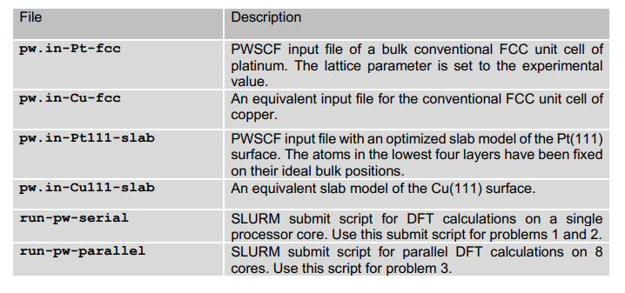

Figure 1: pw.in-Pt-FCC file

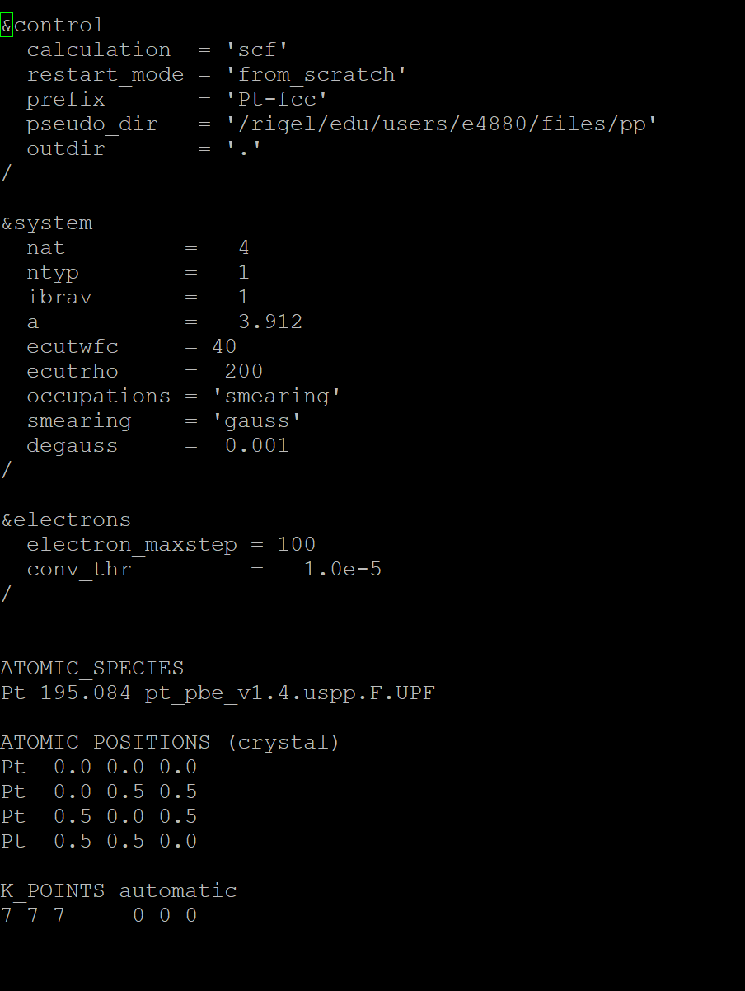

Figure 2: Edited pw.in-Pt-FCC file for CuPt3 alloy of Problem 2B

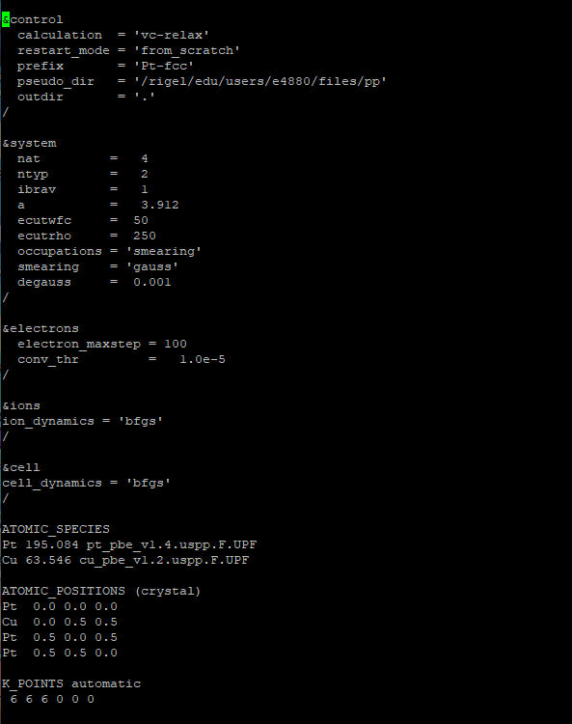

Figure 3: Final Structure for CuPt3

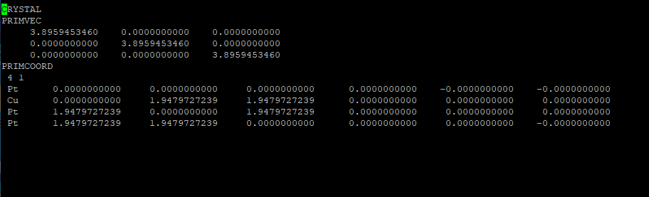

Figure 4: Final Structure for Cu2Pt2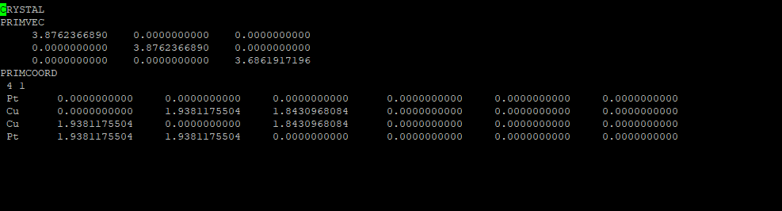

Figure 5: Final Structure for Cu3Pt

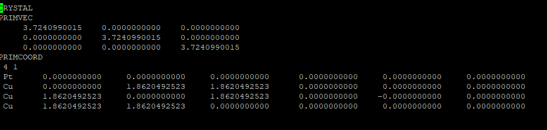

Figure 6: pw.in-Pt111-slab file

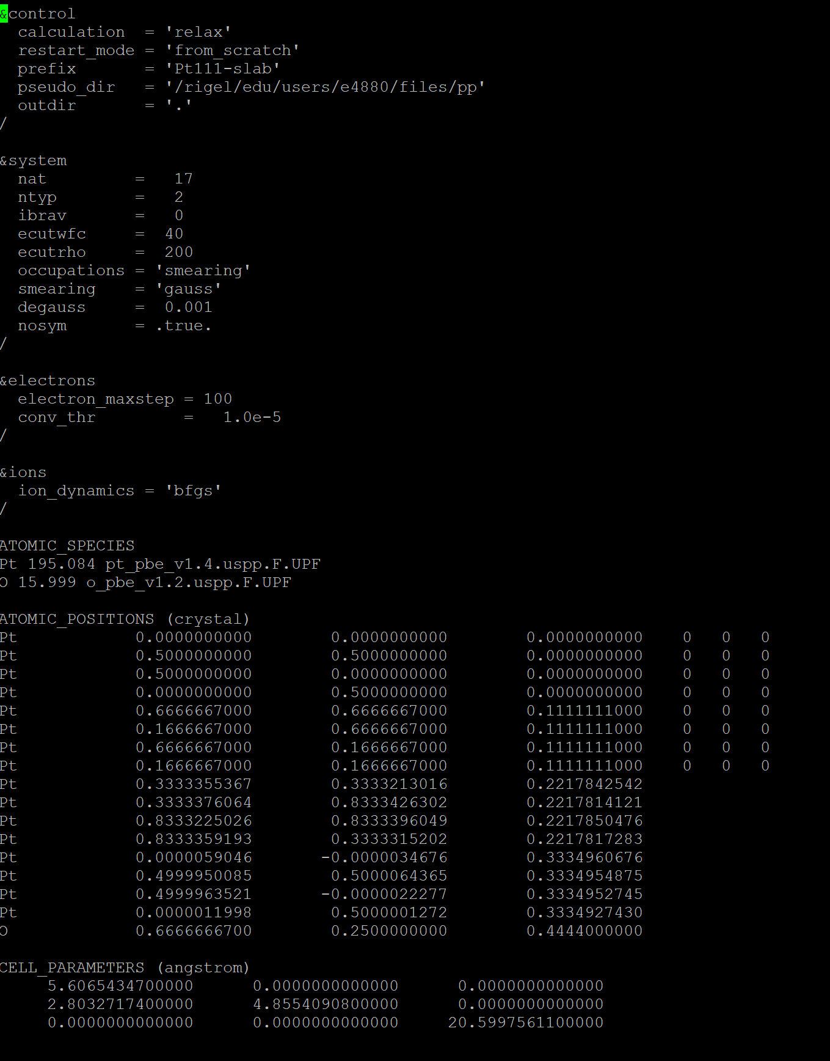

Figure 7: Example of Editing for Atomic Position of Oxygen at On-Top Site

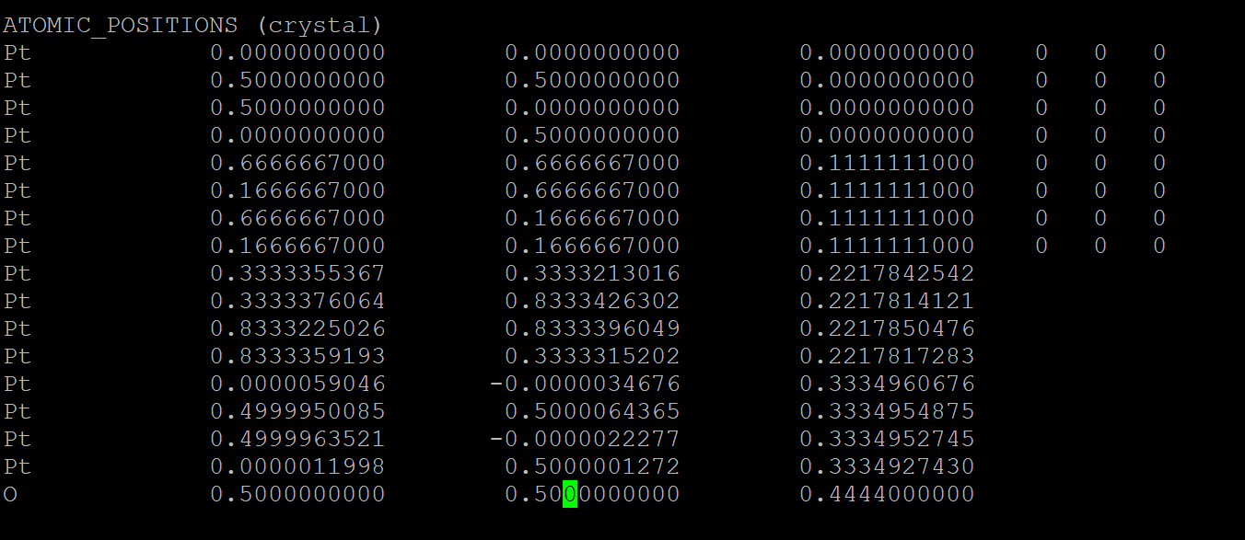

Figure 8: Example of Editing for Atomic Position of Bridge Site

